The data contained in the file “tips1.xlsm” relates to the tip amount (in dollars) collected by a waiter, who worked on four days (Thursday, Friday, Saturday and Sunday). Let us assume that these four days were the only days on which the restaurant stays open. The data contains 244 observations in all. The data also contains information on the total bill amount, sex of the payer of the bill, whether the group of customers contained smokers, the rough time of the day (Lunch/ Dinner) and the size of the group of customers. From this data, we generate a random sample of 120 observations by making use of the RANDBETWEEN function in Excel. The selected 120 observations are an example of unbalanced data as the number of observations for each of the days (Thursday, Friday, Saturday and Sunday), are unequal. The distributions of the tip amounts for each of the 4 days (Thursday, Friday, Saturday and Sunday) is shown by means of grouped boxplot for these 120 observations below.

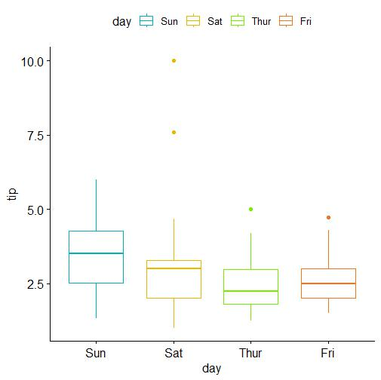

**Fig 1**

From the boxplot it appears that Sunday has the highest mean tip amount. The objective is to test whether the mean tip amount is the same for all the four days (H0). This is done by means of ANOVA of one-way classified data for a fixed effects model. The calculated value of F-statistic comes as 2.55493. The upper 5% value of *F* for 3 and 116 degrees of freedom is 2.68281. Since the calculated value of F is less than the critical value of *F*, we accept, at 5% level, the null hypothesis; that is, we accept that there is no significant difference in the mean tip amounts for the four different days (Thursday, Friday, Saturday and Sunday). The p-value of the test comes as 0.05875. For this fixed effects ANOVA model, the Levene’s test accepts the null hypothesis of homogeneity of variance (p-value comes as 0.8521). But the Shapiro-Wilk test rejects the null hypothesis of normality of residuals (p-value comes as 6.366e-09). The Q-Q plot of residuals is given below.

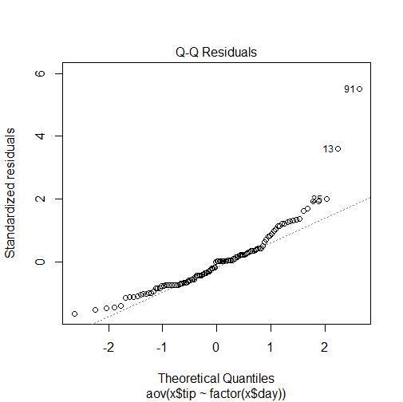  
**Fig 2**

In the QQ-plot we see that the outliers are observation numbers 13, 25 and 91. Now, if we remove these 3 observations from the dataset something interesting happens. If we test the null hypothesis of equality of mean tip amounts for the four days, by means of a *F* test, the null hypothesis is rejected. The calculated value of the *F* statistic comes as 4.058. The upper 5% value of *F* for 3 and 113 degrees of freedom is 2.685. Since the calculated value of *F* is greater than the critical value of *F,* we can reject the null hypothesis of equality of mean tip amounts. The p-value of the test comes as 0.00883. For the ANOVA, using the dataset from which the outliers have been removed, the p-value of the Levene test comes as 0.4243. The p-value of the Shapiro-Wilk test comes as 0.019.

Next, we carry out the least significant difference test to test the equality of the average tip amounts received on any two given days. For example, we test the null hypothesis that the mean tip amounts for Saturday and Sunday are equal (Ho) against the alternative hypothesis that the mean tip amount for Saturday is less than the mean tip amount for Sunday (H1). The results of such tests for all possible pairs of days are shown in the below table. The calculated value of the *t* statistic for the cases where the null hypothesis can be rejected are highlighted in red.

|  |  |  |  |
| --- | --- | --- | --- |
|  | *yio-yi'o* | Calculated *to* | *-t0.05,113* |
| Thur-Fri | -0.16538 | -0.485588 | -1.65845 |
| Fri-Sat | 0.022855 | 0.0723913 |
| Sat-Sun | -0.66644 | -2.900193 |
| Thur-Sat | -0.14253 | -0.577055 |
| Thur-Sun | -0.80897 | -3.076801 |
| Fri-Sun | -0.64359 | -1.960225 |

**Table 1**

*yio* : mean tip amount for the *i*th class (day). *yi’o*: mean tip amount of the *I’th* class (day).

From the table we find that:

* The mean tip amount for Sunday is greater than the mean tip amount for Saturday.
* The mean tip amount for Sunday is greater than the mean tip amount for Thursday.
* The mean tip amount for Sunday is greater than the mean tip amount for Friday.